**Exercise**

**Add a testing widget to your dashboard**

Andy and Mara are excited to show Amita the progress they've made. They've already set up a dashboard. Now they can monitor pull requests and visualize the health of their builds.

In this unit, you add a widget to your dashboard to help visualize your test runs over time.

Amita takes a look and is excited.

**Amita:** This is great progress. Thank you! Not to sound ungrateful, but is there any way I can see just a brief overview of the test results over time?

**Mara:** Yes! Microsoft Azure DevOps lets you add widgets to your dashboards. It only takes a few minutes. Let me show you.

**Add the widget to the dashboard**

1. In your Azure DevOps project, select **Overview**, and then select **Dashboards**.

**Note**

If you ran the template to create the Azure DevOps project, you won't see the dashboard widgets you set up in previous modules.

1. Select **Edit**.
2. In the **Add Widget** pane, search for **Test Results Trend**.
3. Drag **Test Results Trend** to the canvas.
4. Select the gear icon to configure the widget.

a. Under **Build pipeline**, select your pipeline.

b. Keep the other default settings.

1. Select **Save**.
2. Select **Done Editing**.

Although the widget displays only one test run, you now have a way to visualize and track test runs over time. Here's an example that shows a few successful test runs.

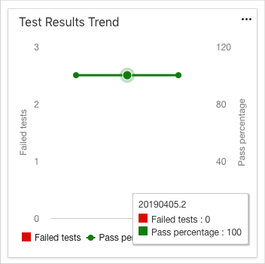

If you begin to see test failures, you can click a point on the graph to navigate directly to that build.